**DEFENCE SERVICES ACADEMY**

**DEPARTMENT OF COMPUTER SCIENCE**

**Enhancing Real-Time Communication in Learning Management Systems Using WebRTC**

**BY**

**MYO MIN THU**

**M.C. Sc Thesis**

**MARCH, 2025**

**PYIN OO LWIN**

**DEFENCE SERVICES ACADEMY**

**DEPARTMENT OF COMPUTER SCIENCE**

**Enhancing Real-Time Communication in Learning Management Systems Using WebRTC**

**Presented By**

**Captain Myo Min Thu**

**Approved by**

**Supervisor**

**Lieutenant Colonel Myo Thant**

**Ph.D. (Computer Science)**

**Assistant Lecturer**

**Department of Computer Science**

**Co-Supervisor**

**Lieutenant Colonel Kyaw Kyaw Khaing**

**Ph.D. (Computer Science)**

**Assistant Lecturer**

**Department of Computer Science**

**March 6, 2025**

# ACKNOWLEDGEMENTS

I would like to express my profound gratitude to **Major General Soe Myat Htut**, Commandant of the Defence Services Academy for allowing me to attend the Master of Computer Science, program at the Defence Services Academy.

I would special thanks to the Rector of the Defence Services Academy, **Brigadier General Thein Lwin**, for his kind permission and encouragement for my Master’s Degree in Computer Science.

I wish to extend my thanks to the person, **Lieutenant Colonel Soe Win Myint**, Head of the Department of Computer Science at the Defence Services Academy, for his close support in doing thesis work, attending seminars, and giving valuable advice and guidance for the preparation of this thesis.

I am highly indebted to **Lieutenant Colonel Zar Nay Lin,** who is responsible for the Master of Computer Science at the Defence Services Academy, for his immense patience and for providing an incredible amount of guidance.

I must particularly express my thankfulness to my coaches, **Major Ye Wint Mg Mg**, Assistant Lecturer and supervisor, and **Major Myo Min Hein,** Assistant Lecturer and co-supervisor, Department of Computer Science at Defence Services Academy, for valuable advice, their close supervision, kind guidance and support, and cooperation of master degree program, and I realized the valuable suggestions, understanding, and generous encouragements during a long period of study for thesis paper. I am also grateful to **Captain Aung Myint Myat**, Department of Computer Science, for his helping with editing. Last but not least, many thanks to all persons who directly and indirectly contributed toward the completion of this thesis.

ABSTRACT

The advent of digital learning environments has necessitated the development of robust communication tools to facilitate effective interaction between learners and educators. This thesis explores the integration of Web Real-Time Communication (WebRTC) into Learning Management Systems (LMS) to enhance real-time communication features such as video conferencing, voice calls, and screen sharing. The study aims to design, implement, and evaluate a WebRTC-based communication module within an existing LMS. Through a combination of functional and performance testing, user studies, and data analysis, this research investigates the impact of WebRTC on user engagement, system performance, and educational outcomes. The findings provide insights into the benefits and challenges of incorporating real-time communication technologies in online learning platforms, offering recommendations for future enhancements in educational technology.

**Keywords**: AJAX (Asynchronous JavaScript and html), Data Collection, LMS

# TABLE OF CONTENTS

**Page**

ACKNOWLEDGEMENTS i

ABSTRACT ii

TABLE OF CONTENTS iii

LIST OF ABBREVIATION vi

LIST OF TABLES viii

LIST OF EQUATIONS ix

**CHAPTER** **TITLE**

1 INTRODUCTION 1

1.1 Problem Statement 2

1.2 Motivation 2

1.3 Aim of thesis 3

1.4 Objectives of thesis 3

1.5 Overview of the System 3

1.6 Organization of Thesis 4

2 BACKGROUND KNOWLEDGE 5

2.1 History of World Wide Web 5

2.2 Web Page 6

2.2.1 Static Web Page 6

2.2.2 Dynamic Web Pages 8

2.3 Hypertext Transfer Protocol (HTTP) 8

2.4 XAMPP 9

2.5 Learning Management System(LMS) 11

2.5.1 Used of LMS 10

2.5.2 Common Features of LMS 10

Table of Contents (Continued)

2.5.3 Types of LMS 10

2.6 WEB Real-Time Communication 12

2.7 MediaSream (getUserMedia) 14

2.8 RTCPeerConnection 14

2.9 RTCDataChannel 14

2.10 Summary 14

3 SYSTEM DESIGN AND IMPLEMENTATION 27

3.1 Work Flow of the System 27

3.2 Proposed System Design of WebRTC 27

3.2 Overall Design of the System 28

3.3 Detail Design of Learning Room 29

3.4 Implementation 29

4 CONCLUSION AND FUTURE WORK 45

4.1 Conclusion 45

4.2 Benefits of the System 46

4.3 Limitation 46

4.4 Further Extension 47

REFERENCES

APPENDICES

CHAPTER 1

# INTRODUCTION

The advent of digital technologies has revolutionized the educational landscape, leading to the widespread adoption of Learning Management Systems (LMS) in both academic and corporate settings. LMS platforms serve as comprehensive frameworks that support the administration, documentation, tracking, reporting, and delivery of educational courses or training programs. Despite their extensive functionalities, traditional LMS platforms often lack robust real-time communication tools, which are crucial for creating engaging and interactive learning environments. This gap has become more pronounced in the context of remote learning, where the need for synchronous communication is paramount.

Web Real-Time Communication (WebRTC) is an open-source project that provides web applications and websites with real-time communication capabilities via simple application programming interfaces (APIs). WebRTC enables peer-to-peer audio, video, and data sharing without the need for plugins, offering a seamless and efficient communication solution. Its integration into LMS platforms has the potential to address the limitations of existing communication tools, enhancing the overall learning experience.

The primary objective of this thesis is to investigate the integration of WebRTC into an LMS to improve real-time communication. This research aims to design, implement, and evaluate a WebRTC-based communication module that facilitates video conferencing, voice calls, and screen sharing. The study will examine the impact of this integration on user engagement, system performance, and educational outcomes.

The theoretical framework for this research is grounded in the constructivist learning theory and media richness theory. Constructivist learning theory posits that learners construct knowledge through experiences and interactions, highlighting the importance of active engagement and collaboration in the learning process. Media richness theory suggests that the effectiveness of communication is influenced by the richness of the media used. WebRTC, with its high bandwidth for transmitting audio and video, exemplifies a rich medium that can significantly enhance the quality of interactions in an LMS.

The methodology of this study involves several key phases: a comprehensive literature review, the design and implementation of the WebRTC module, testing and validation, user studies, and data analysis. The literature review will provide a foundation for understanding the current state of LMS communication tools and the potential benefits of WebRTC. The design and implementation phase will focus on creating a functional WebRTC module integrated into an existing LMS. Testing and validation will ensure the reliability and scalability of the module, while user studies will gather qualitative and quantitative data on user satisfaction and learning outcomes. Data analysis will synthesize these findings to evaluate the overall impact of the WebRTC integration.

In conclusion, this thesis aims to contribute to the field of educational technology by demonstrating how WebRTC can enhance real-time communication in LMS platforms. By improving the tools available for synchronous learning, this research seeks to foster more interactive and engaging educational experiences, ultimately supporting better educational outcomes.

1. Problem Statement

In the evolving landscape of digital education, Learning Management Systems (LMS) have become integral tools for delivering and managing educational content. However, many existing LMS platforms rely on outdated or limited communication tools that hinder real-time interaction between students and instructors. Traditional LMS communication features often lack the richness and immediacy required for effective synchronous learning experiences, such as video conferencing, voice calls, and real-time collaboration.

Web Real-Time Communication (WebRTC) offers a modern solution to these challenges by providing robust, real-time communication capabilities directly within web browsers without the need for additional plugins. Despite its potential, the integration of WebRTC into LMS platforms has not been widely explored or implemented. This gap in the current state of LMS communication tools presents a significant opportunity to enhance synchronous learning environments.

The problem addressed by this thesis is the inadequacy of existing communication tools in LMS platforms and the potential of WebRTC to address these deficiencies. Specifically, the research aims to:

1. Assess the limitations of current communication tools within LMS platforms that affect real-time interaction and engagement.
2. Explore the integration of WebRTC technology into LMS platforms to enhance synchronous communication features, including video conferencing, voice calls, and screen sharing.
3. Evaluate the impact of WebRTC integration on user engagement, system performance, and educational outcomes in a real-world educational setting.

By addressing these issues, the thesis seeks to provide a comprehensive solution for improving real-time communication within LMS platforms, thereby enhancing the overall learning experience and fostering more interactive and collaborative educational environments.

## 1.2 Motivation

The increasing adoption of online learning platforms, particularly Learning Management Systems (LMS), has transformed the education landscape by providing students and educators with flexible and accessible learning environments. However, the demand for effective real-time communication in these platforms has become more pressing, especially as online education expands in scope and sophistication. Traditional communication tools embedded in LMSs often lack the ability to offer seamless, real-time interactions that mimic the immediacy and engagement of in-person learning.

Web Real-Time Communication (WebRTC) technology presents a promising solution to this challenge by enabling high-quality, low-latency audio, video, and data communication directly through web browsers, without requiring additional plugins. Integrating WebRTC into LMSs can significantly improve the interactive experience for learners and educators, fostering more dynamic, engaging, and collaborative learning environments.

This thesis is motivated by the need to enhance real-time communication capabilities in LMSs, addressing the current gaps in online education platforms by leveraging WebRTC technology. The study aims to explore how WebRTC can be effectively integrated into LMSs to provide improved live lectures, discussions, peer-to-peer collaboration, and real-time feedback mechanisms. By investigating this integration, the thesis seeks to contribute to the evolution of online education by creating more engaging and interactive digital learning experiences, ultimately benefiting both students and educators.

## 1.3 Aim of thesis

The primary aim of this thesis is to enhance real-time communication within Learning Management Systems (LMS) by integrating Web Real-Time Communication (WebRTC) technology. The goal is to facilitate improved synchronous learning experiences, fostering greater interaction, engagement, and collaboration among users, ultimately leading to better educational outcomes.

## 1.4 Objectives of thesis

The objectives of system are as follows;

(a) To implement key features such as video conferencing, voice calls, and screen sharing to support real-time communication and collaboration.

(b) To perform functional testing to ensure the WebRTC module operates correctly within the LMS, addressing potential issues related to compatibility, reliability, and usability.

(c) To conduct a thorough review of current communication tools integrated into Learning Management Systems (LMS) to identify their strengths and limitations.

(d) To perform comprehensive usability testing with educators and students to assess the effectiveness, ease of use, and reliability of the WebRTC communication module.

## 1.5 Overview of the System

The proposed system aims to enhance real-time communication within Learning Management Systems (LMS) by integrating Web Real-Time Communication (WebRTC) technology. WebRTC is an open-source project that facilitates peer-to-peer communication through web browsers, enabling high-quality audio, video, and data sharing without requiring external plugins. This system is designed to overcome the limitations of traditional LMS communication tools, which often lack the immediacy and engagement of live interactions.

The system architecture is composed of the following key components:

1. **WebRTC Integration**  
   The core feature of the system is the integration of WebRTC into the LMS. This allows students and educators to engage in real-time communication directly from their browsers, without needing third-party software. WebRTC supports live video and audio sessions, text chat, screen sharing, and data transfer, providing a robust communication platform that meets the diverse needs of online education.
2. **User Interface (UI)**  
   The system features a user-friendly interface embedded within the LMS that facilitates seamless access to WebRTC-powered communication tools. Educators can initiate live video lectures, group discussions, and one-on-one consultations, while students can participate in real-time collaboration sessions with peers and instructors. The UI ensures minimal disruption to the learning process, making it easy to switch between course materials and live communication sessions.
3. **Session Management**  
   A session management module is included to handle scheduling, participation, and coordination of live communication sessions. The system allows educators to schedule live classes, webinars, or office hours within the LMS, ensuring that students receive timely notifications and reminders. Additionally, it manages participant authentication, ensuring secure access to sessions.
4. **Real-Time Collaboration Features**  
   Beyond live video and audio communication, the system also supports real-time data sharing and collaboration. Students and instructors can exchange files, work on shared documents, and use a virtual whiteboard to enhance interaction during live sessions. This feature fosters a collaborative learning environment, enabling real-time problem-solving and group activities.
5. **Scalability and Performance Optimization**  
   The system is designed to handle multiple concurrent users without compromising performance. By using WebRTC’s peer-to-peer architecture, the system minimizes server load, ensuring that large numbers of students can participate in live sessions simultaneously. This scalability ensures that institutions of varying sizes can implement the system without performance issues.
6. **Security and Privacy**  
   WebRTC provides end-to-end encryption for all communication, ensuring the privacy and security of live sessions. The system also includes authentication and authorization mechanisms within the LMS to control access to communication features, ensuring that only registered users can participate in sessions.
7. **Cross-Platform Compatibility**  
   The system is designed to be compatible across various platforms, including desktops, tablets, and smartphones, allowing users to access real-time communication features from any device with a modern web browser.

## 1.6 Organization of the System

This system is organized as follows: In chapter one, introduction and objectives are described. Chapter two presents the literature review and also presents all of background theories for our proposed system. In chapter three, the proposed systems present. Chapter four describes the conclusion and future works.

# CHAPTER 2

# THEORETICAL BACKGROUND

In this chapter, the history of world wide web, web page, Hypertext Transfer Protocol (HTTP), XAMPP, Hypertext Markup Language (HTML), Hypertext Preprocessor (PHP) are presented. This thesis is based on Model-1 Architecture.

## 2.1 History of World Wide Web

The World Wide Web, commonly known as the web, emerged in the late 20th century as a revolutionary system for accessing and sharing information over the internet. It was conceived by British computer scientist Tim Berners-Lee in 1989 while he was working at CERN, the European Organization for Nuclear Research. Berners-Lee's vision was to create a distributed information system that would allow researchers to share documents and data more efficiently. In 1990, Berners-Lee developed the foundational technologies for the web, including Hypertext Markup Language (HTML) for creating web pages, Uniform Resource Identifiers (URIs) for identifying resources, and Hypertext Transfer Protocol (HTTP) for transmitting data over the internet. He also created the first web browser/editor (World Wide Web) and web server (http) to demonstrate the capabilities of the web.

The web gained widespread popularity in the mid-1990s with the release of graphical web browsers like Mosaic and Netscape Navigator, which made it easier for users to navigate and interact with web pages. This period, known as the "dot-com boom," saw exponential growth in the number of websites, online businesses, and internet users, transforming the way people communicate, access information, and conduct commerce worldwide.[12]

## 2.2 Web Page

A web page is a fundamental unit of information on the World Wide Web, consisting of content organized within a single HTML document. It serves as a digital document accessible through a web browser and is often part of a larger website or web application. Web pages can vary widely in content and purpose, ranging from static pages displaying text and images to dynamic pages with interactive elements and multimedia content. Structurally, a web page typically includes HTML markup to define the structure and layout of the content, CSS styles to control its presentation and appearance, and JavaScript code to add interactivity and functionality.

The content of a web page can be diverse, encompassing textual information, images, videos, audio files, forms, and interactive elements such as buttons and links. Web pages may also include metadata such as page titles, descriptions, and keywords to optimize search engine visibility and accessibility. Additionally, modern web pages often incorporate responsive design techniques to ensure compatibility and usability across various devices and screen sizes. Web pages are accessed by users through a web browser, which retrieves the page from a web server and renders it for display. Users can navigate between web pages by clicking on hyperlinks or using navigation menus provided within the page. With the proliferation of the internet, web pages have become an integral part of daily life, serving as a primary means of accessing information, conducting business transactions, communicating with others, and engaging with online content. [16,14]

There are two basic types of web pages:

1. Static Web Pages
2. Dynamic Web Pages

### 2.2.1 Static Web Page

Static Web Pages are made of “fixed code,” and unless the site developer makes changes, nothing will change on the page. Static sites give a lot of the same type of information that the user could get from a brochure, but it can’t just change itself. In order to do this, someone has to create a new page. That’s why static websites are sometimes referred to as brochure sites. [15]

Nothing is stored but the actual pages of a static site. There are:

1. No users
2. No comments
3. No blog posts
4. No interactivity

A static website is delivered to a user exactly the way it’s stored. That means that nothing on the page will change by the user or even the site administrator unless there’s a redesign of the site, or the site administrator goes directly into the code to change it. A static site is the most basic kind of website, and the easiest to create. It requires no server-side (also called back-end) processing, only client-side. Client-side technologies are [HTML, CSS, and JavaScript](https://www.pluralsight.com/paths/building-websites-with-html-css-and-javascript).

No programming languages, including JavaScript, are required to make a static site. However, if a site utilizes JavaScript, but no [PHP](https://www.pluralsight.com/paths/php-development-fundamentals) or any other programming language, it’s still considered a static site (since JavaScript is a client-side language). So, if the user wants a site only to give information that doesn’t need to be updated regularly, creating a static website is a simple and effective way to go.[15] The static web page is shown in Figure 2.1.

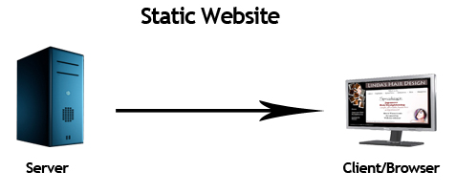

Figure 2.1 Static Web Page

### 2.2.2 Dynamic Web Pages

A dynamic web page is a type of webpage that displays different content each time it's viewed. Unlike static pages, which have fixed content, dynamic pages are generated on the fly, usually by pulling data from a database or other external source. This allows for personalized content tailored to each user, as well as real-time updates and interactions. Dynamic pages often utilize technologies like HTML, CSS, JavaScript, and server-side scripting languages such as PHP, Python, or Ruby on Rails. Examples of dynamic web pages include social media feeds, news websites with constantly updating articles, and e-commerce sites that display products based on user preferences. Their flexibility and interactivity make dynamic web pages essential for modern internet experiences.[18]

There’s a simple way to determine if a site is dynamic. If the user can interact with it, it’s a dynamic site. For example, dynamic sites allow the user to create a user profile, comment on a post, or make a reservation.

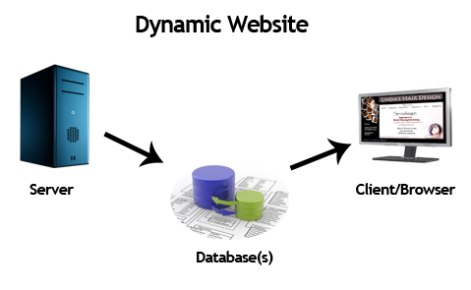

Figure 2.2 Dynamic Web Page

## 2.4 XAMPP

XAMPP is a free and open-source cross-platform web server solution stack package developed by Apache Friends, consisting mainly of the Apache HTTP Server, MariaDB database, and interpreters for scripts written in PHP and Perl [13]. The name "XAMPP" stands for:

1. X: Stands for cross-platform, indicating that it is available on multiple operating systems.
2. A: Apache HTTP Server, the web server software.
3. M: MariaDB, which is a fork of MySQL and serves as the database component.
4. P: PHP, a popular scripting language used for web development.
5. P: Perl, another scripting language often used for web applications.

XAMPP is designed to be an easy-to-install and ready-to-use web server package. It allows developers to set up a local web server environment on their own computer for testing and development purposes. This local server environment enables developers to create and test web applications, websites, and content locally before deploying them to a live server on the internet.

Some key features of XAMPP are:

1. Easy Installation: XAMPP provides a straightforward installation process, making it accessible to beginners and experienced developers alike.
2. Cross-Platform: XAMPP is available for Windows, macOS, Linux, and Solaris, making it a versatile choice for developers using different operating systems.
3. All-in-One Package: XAMPP includes all the necessary components for a web server environment, including Apache, MariaDB (or MySQL), PHP, and Perl. This eliminates the need to install and configure these components individually.
4. Modularity: While XAMPP comes with a predefined configuration, users can easily modify settings, enable or disable modules, and customize the server environment to match their specific requirements.
5. Development and Testing: XAMPP is ideal for local development and testing of web applications. Developers can work on their projects offline and test them in a secure environment before going live on the internet.
6. User-Friendly Control Panel: XAMPP provides a user-friendly control panel that allows users to start and stop the Apache server, MySQL database, and other components with just a few clicks.

It's important to note that while XAMPP is excellent for local development and testing, security considerations are essential when deploying web applications to production servers. Developers should follow best practices for securing their web servers and databases to ensure the safety of their applications and data.[17]

## 2.5 Learning management System(LMS)

A learning management system is a software application or web-based technology used to plan, implement and assess a specific learning process. It's used for e-learning practices and, in its most common form, consists of two elements: a server that performs the base functionality and a user interface ([UI](https://www.techtarget.com/searchapparchitecture/definition/user-interface-UI)) that is operated by instructors, students and administrators.

Typically, an LMS provides an instructor with a way to create and deliver content, monitor student participation, and assess student performance. It might also provide students with interactive features, such as [threaded](https://www.techtarget.com/whatis/definition/thread) discussions, [video conferencing](https://www.techtarget.com/searchunifiedcommunications/definition/video-conference) and discussion forums.

Businesses, government agencies, and traditional and online educational institutions often use these systems. They can improve traditional educational methods, while also saving organizations time and money. An effective system lets instructors and administrators efficiently manage elements such as user registration and access, content, calendars, communication, quizzes, certifications and notifications.

The Advanced Distributed Learning group, sponsored by the U.S. Department of Defense, has created a [set of specifications](https://adlnet.gov/past-projects/scorm/) called the Sharable Content Object Reference Model (SCORM) to encourage the standardization of LMSes.

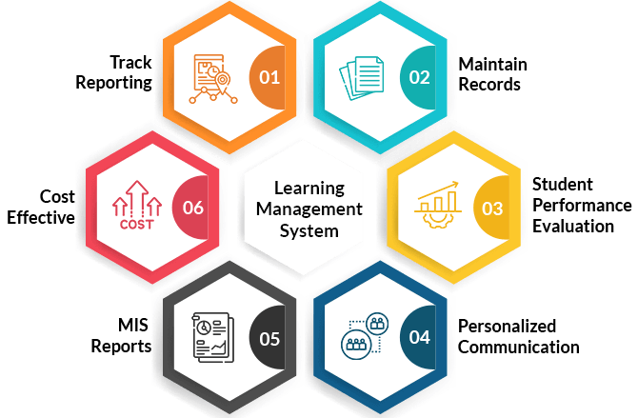

## Used of Learning management System (LMS)

LMSes are beneficial to a range of organizations, including higher education institutions and companies. They're primarily used for [knowledge management](https://www.techtarget.com/searchcontentmanagement/definition/knowledge-management-KM): the gathering, organizing, sharing and analysis of an organization's knowledge in terms of resources, documents and people skills. The role of the LMS varies according to the organization's training strategy and goals.

1. **Onboarding and training**

Employee training and [onboarding](https://www.techtarget.com/searchhrsoftware/definition/employee-onboarding-and-offboarding) are two common uses of LMSes in a business environment. For onboarding, the LMS helps train new employees, providing opportunities to access training programs across various devices. New employees are able to add their own knowledge and provide feedback, helping employers understand how effective the training course materials are and identify areas where new hires need assistance.

An LMS can be used for extended enterprise training purposes as well. This includes customer, partner and member training. Customer learning activities are common in software and technology companies where user learning goals might include learning how to use a product or system. Ongoing LMS-based customer training improves the [customer experience](https://www.techtarget.com/searchcustomerexperience/definition/customer-experience-CX) and can increase [brand](https://www.techtarget.com/whatis/definition/brand) loyalty.

When using an LMS for these purposes, instructors can create immersive learning experiences that let users develop new skills and problem-solving capabilities. For example, an LMS could be used to create tutorials that incorporate [augmented reality](https://www.techtarget.com/whatis/definition/augmented-reality-AR), virtual reality and artificial intelligence (AI). This will likely have the effect of improving creativity and innovation throughout the workforce.

1. **Development and retention**

Employee development and [retention](https://www.techtarget.com/searchhrsoftware/definition/employee-retention) is another way LMSes are used in businesses. The system assigns courses to employees to ensure they are developing effective job skills, remain informed about product changes, and have requisite product and [compliance](https://www.techtarget.com/searchdatamanagement/definition/compliance) knowledge.

1. **Sales training**

Another way LMSes are used is to enhance employee sales skills. This includes the creation of seminars on product knowledge, customer interaction training and case study-based tutorials that use previous experiences with clients to improve future interactions.

1. **Blended learning**

An LMS can provide students with blended learning experiences that combine traditional classroom teaching with online learning tools. This method is more effective than simple face-to-face education because it enriches instructor-led training in the classroom with digital learning content customized to fit a student's learning needs.

## Common features of Learning management System (LMS)

An LMS can be thought of as a large repository where users store and track information in one place. Any user with a login and password can access the system and its online learning resources. If the system is self-hosted, the user must either install the software on their computer or access it via their company's server.

[Some common LMS features](https://www.techtarget.com/searchhrsoftware/tip/What-makes-a-good-learning-management-system) include the following capabilities and technologies:

1. **Responsive design.**Users can access the LMS from any type of device, whether it's a desktop, laptop, tablet or smartphone. The system automatically displays the version best suited for each user's chosen device and lets users download content for offline work.
2. **User-friendly interface.**The UI lets learners navigate the LMS platform and is aligned with the abilities and goals of the user and the organization. An unintuitive UI risks confusing or distracting users and will make the LMS less effective.
3. **Reports and analytics.**E-learning assessment tools show instructors and administrators how effective online training initiatives are. Both groups of learners and individuals can be analyzed with these tools and metrics.
4. **Catalog and course management.**Admins and instructors manage the catalog of course content in the LMS to create more targeted learning experiences.
5. **Content interoperability and integration.**Content created and stored in an LMS must be packaged in accordance with interoperable standards, including SCORM and [xAPI](https://www.techtarget.com/searchhrsoftware/definition/xAPI-experience-API).
6. **Support services.** [Different LMS vendors](https://www.techtarget.com/searchhrsoftware/tip/Top-learning-management-systems) offer varying levels of support. Many provide online discussion boards where users can connect and help each other. Additional support services, such as a dedicated, toll-free phone number, might be available for an extra cost.
7. **Certification and compliance support.** This feature is essential to systems used for online compliance training and certifications. Instructors and admins assess an individual's skill set and identify any gaps in their performance. This feature also makes it possible to use LMS records during an audit.
8. **Social learning capabilities.**Many LMSes include [social media](https://www.techtarget.com/whatis/definition/social-media) tools in their learning platforms to let users interact with their peers, collaborate and share learning experiences.
9. **Gamification.**Some LMSes include game mechanics or built-in gamification features that add extra motivation and engagement to courses. This gives students additional incentive to complete courses, in the form of leaderboards, points and badges.
10. **Automation.**Learning management systems automate repeated and tedious tasks, such as grouping, adding and deactivating users, and handling group enrollments.
11. **Localization.**LMSes often include multilingual support, removing language barriers from learning and training content. Some LMSes integrate geolocation features that automatically present the appropriate version of the course when a user accesses it.
12. **Artificial intelligence.**LMSes use AI to create personalized learning experiences for users with course formats suited to their needs. AI also helps suggest topics a user might find interesting based on the courses they've already completed.

## Types of Learning management System (LMS) deployments

The [different LMS deployment options](https://www.techtarget.com/searchhrsoftware/tip/Learn-the-6-types-of-learning-management-systems) include the following:

1. **Cloud-based**LMSes are hosted on the [cloud](https://www.techtarget.com/searchcloudcomputing/definition/cloud-computing) and often follow a software as a service ([SaaS](https://www.techtarget.com/searchcloudcomputing/definition/Software-as-a-Service)) business model. Providers maintain the system and handle updates or upgrades. Online users can access the system apps from anywhere at any time using a username and password.
2. **Self-hosted**LMSes require the organization to download and install the LMS software. The self-hosted platform provides creative control and customization, but the organization is responsible for maintaining the system and might also have to pay for updates.
3. **Third-party hosted** LMSes are also learning resources hosted by a third-party organization. Courses can be obtained directly from a [public cloud](https://www.techtarget.com/searchcloudcomputing/definition/public-cloud) location, or from the training company's own data center or [private cloud](https://www.techtarget.com/searchcloudcomputing/definition/private-cloud).
4. **Desktop application LMSes** are installed on the user's desktop. However, the application might still be accessible on multiple devices.
5. **Mobile application LMSes** support a mobile learning environment and are accessible wherever and whenever through mobile devices. This platform deployment type lets users engage with and track their online learning initiatives on the go.

## Benefits of Learning management System (LMS) deployments

An LMS can save an organization time and money. Instead of making learners take time out of their day to travel and sit through classes or training at another location, LMSes let them complete the coursework at a time and in a place that's best for them. In addition, LMSes eliminate the need for instructors, training days, training materials, travel expenses and location hiring.

[Some other benefits of learning management systems](https://www.techtarget.com/searchhrsoftware/tip/Benefits-of-a-learning-management-system) include the following:

1. The ability to monitor users' learning progress and performance.
2. Increased e-learning accessibility without geographic limitations.
3. Personalized online courses, training and learning experiences.
4. The ability to easily and efficiently update e-learning modules and activities.
5. Consistent and easy distribution of online training and learning content across an organization.
6. Elimination of repetitive tasks, such as user enrollment and certification.
7. Centralized learning that lets an organization organize and store all data in one place, making it easier for instructors and admins to update and maintain learning materials.
8. Advanced [encryption](https://www.techtarget.com/searchsecurity/definition/encryption) features to keep data and content secure.

## 2.6 Web Real-Time Communication

WebRTC (Web Real-Time Communication) is a [free and open-source](https://en.wikipedia.org/wiki/Free_and_open-source_software) project providing [web browsers](https://en.wikipedia.org/wiki/Web_browser) and [mobile applications](https://en.wikipedia.org/wiki/Mobile_application) with [real-time communication](https://en.wikipedia.org/wiki/Real-time_communication) (RTC) via [application programming interfaces](https://en.wikipedia.org/wiki/API) (APIs). It allows audio and video communication and streaming to work inside web pages by allowing direct [peer-to-peer](https://en.wikipedia.org/wiki/Peer-to-peer) communication, eliminating the need to install [plugins](https://en.wikipedia.org/wiki/Plug-in_(computing)) or download native apps.

Supported by [Apple](https://en.wikipedia.org/wiki/Apple_Inc.), [Google](https://en.wikipedia.org/wiki/Google), [Microsoft](https://en.wikipedia.org/wiki/Microsoft), [Mozilla](https://en.wikipedia.org/wiki/Mozilla), and [Opera](https://en.wikipedia.org/wiki/Opera_(company)), WebRTC specifications have been published by the [World Wide Web Consortium](https://en.wikipedia.org/wiki/World_Wide_Web_Consortium) (W3C) and the [Internet Engineering Task Force](https://en.wikipedia.org/wiki/Internet_Engineering_Task_Force) (IETF).

According to the webrtc.org website, the purpose of the project is to "enable rich, high-quality RTC applications to be developed for the browser, mobile platforms, and [IoT](https://en.wikipedia.org/wiki/Internet_of_things) devices, and allow them all to communicate via a common set of [protocols](https://en.wikipedia.org/wiki/Communication_protocol)"**.**

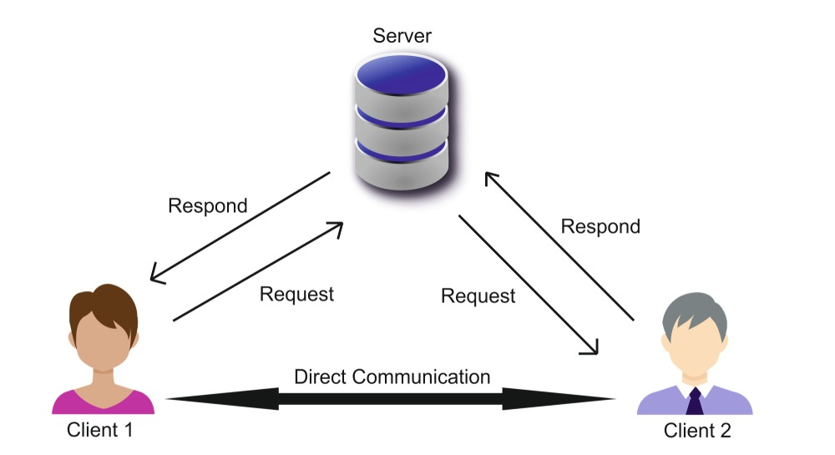

## 2.7 MediaStream (getUserMedia)

MediaStream (getUserMedia) is a fundamental API in Web Real-Time Communication (WebRTC) that enables web applications to access media devices, such as cameras and microphones, to capture audio and video streams directly from the user's device. This API is critical for creating interactive and engaging applications that require real-time media capture, such as video conferencing, online gaming, and virtual classrooms.

**Key Features of MediaStream (getUserMedia):**

1. **Media Capture:** The primary function of getUserMedia is to allow web applications to capture media streams from the user's camera and microphone. This enables the creation of rich, multimedia experiences that incorporate live video and audio.
2. **User Permissions:** For security and privacy reasons, getUserMedia requires explicit user permission before accessing media devices. This ensures that users have control over when and how their media devices are used by web applications.
3. **Flexible Media Constraints:** The API supports various media constraints that allow developers to specify the desired characteristics of the media streams. These constraints include video resolution, frame rate, and audio quality, providing flexibility to optimize the media capture for different use cases.
4. **Integration with WebRTC:** Media streams captured via getUserMedia can be easily integrated with WebRTC's RTCPeerConnection for real-time peer-to-peer communication. This seamless integration is essential for building applications like video chat and online collaboration tools.
5. **Handling Multiple Media Sources:** getUserMedia can handle multiple media sources, enabling applications to capture and utilize streams from more than one device, such as using both front and rear cameras on a mobile device simultaneously.

**Applications of MediaStream (getUserMedia):**

1. **Video Conferencing:** Video conferencing applications rely heavily on getUserMedia to capture live video and audio from participants. This API enables real-time communication, making remote meetings and virtual collaborations possible.
2. **Online Education:** In virtual classrooms, getUserMedia is used to capture live lectures and student presentations, facilitating interactive and engaging online learning experiences.
3. **Live Streaming:** MediaStream is crucial for live streaming platforms that broadcast real-time content, such as webinars, live events, and gaming streams.
4. **Telemedicine:** Telemedicine applications use getUserMedia to enable live video consultations between healthcare providers and patients, improving access to medical care and allowing remote diagnosis and treatment.
5. **Augmented Reality (AR):** AR applications can use getUserMedia to capture the real-world environment, overlaying digital information and enhancing the user's interaction with their surroundings.

**Technical Components:**

1. **getUserMedia API:** The getUserMedia API is the entry point for accessing the user's media devices. It prompts the user for permission and, upon approval, provides a MediaStream object containing the requested media tracks.
2. **MediaStream Object:** The MediaStream object represents the media stream captured from the user's devices. It contains one or more MediaStreamTrack objects, each representing an individual media source, such as a camera or microphone.
3. **Media Constraints:** Developers can specify media constraints to control the characteristics of the media streams. Constraints can include properties like video resolution, frame rate, and audio quality.

## 2.8 RTCPeerConnection

RTCPeerConnection is a core component of the Web Real-Time Communication (WebRTC) technology, enabling real-time, peer-to-peer communication between browsers or devices over the internet. It is responsible for establishing, maintaining, and managing direct connections for audio, video, and data transmission without the need for an intermediary server, making it highly efficient for real-time applications like video conferencing, voice calls, or collaborative tools.

The RTCPeerConnection object handles several key tasks during communication:

1. Establishing Peer Connections: RTCPeerConnection initiates and manages connections between peers. It uses signaling protocols (like SDP—Session Description Protocol) to exchange connection details (ICE candidates, media capabilities) between peers to set up the connection.
2. Media and Data Transmission: Once a connection is established, RTCPeerConnection manages the transmission of media streams (audio and video) and data channels. These streams can include video conferencing sessions, audio calls, or other media shared between peers in real time.
3. Network Traversal and ICE Framework: RTCPeerConnection uses Interactive Connectivity Establishment (ICE) to handle network traversal, enabling communication even across NAT (Network Address Translation) or firewall-protected networks. ICE gathers possible connection candidates (IP addresses and ports) from both peers and determines the most efficient route for direct communication.
4. Security and Encryption: RTCPeerConnection ensures that all data transmitted between peers is secure by enforcing end-to-end encryption, a critical feature for ensuring the privacy and security of the communication.
5. Bandwidth Management: RTCPeerConnection manages the quality of media streams based on available bandwidth, adjusting the bitrate or resolution of video to ensure smooth communication under varying network conditions.

In summary, RTCPeerConnection is the core API in WebRTC that enables browsers or devices to establish secure and efficient real-time communication channels for media and data. It handles everything from connection setup and media exchange to encryption and network traversal, making it an essential tool for developing real-time applications like video calls, live streaming, and collaborative platforms.

## 2.9 ****RTCDataChannel****

The **RTCDataChannel** is a key feature of the WebRTC (Web Real-Time Communication) API, enabling the transmission of arbitrary data between peers in a peer-to-peer (P2P) connection. This capability makes WebRTC more than just a tool for audio and video communication; it also allows for real-time data sharing in a flexible and efficient manner.

The RTCDataChannel API allows WebRTC applications to exchange data directly between browsers or devices without the need for intermediary servers. It is designed to support various use cases, including but not limited to:

1. Text-based messaging
2. File transfer
3. Synchronization of game states in multiplayer gaming
4. Real-time collaborative editing
5. IoT data streaming

RTCDataChannel relies on the RTCDataConnection established using the WebRTC framework. The data channel is created over the peer-to-peer connection, which is set up via ICE (Interactive Connectivity Establishment), STUN (Session Traversal Utilities for NAT), and TURN (Traversal Using Relays around NAT) servers to manage network traversal.

The RTCDataChannel can be created in two ways:

1. Active Creation: Using the createDataChannel method of the RTCPeerConnection object on one peer.
2. Passive Listening: The other peer listens for an incoming data channel through the ondatachannel event handler.

## 2.10 Summary

The proposed Automated Tourist Destination Recommendation System combines these theoretical foundations to provide a robust solution. By utilizing collaborative filtering and geolocation data, the system can offer highly personalized and contextually relevant travel suggestions. Machine learning algorithms analyze vast amounts of user data to predict preferences accurately, while feedback mechanisms ensure continuous improvement of the recommendation model.

This integration of advanced technologies and theories not only enhances the user experience but also represents a significant advancement in the field of travel planning and recommendation systems.

# CHAPTER 3

# SYSTEM DESIGN AND IMPLEMENTATION

This chapter presents the system design, detail design, database design and implementations of the system.

## 3.1 Work Flow of the System

There are three roles in the work flow of the system. They are Services repository, visitor profiles and planning a personalized trip. This system considers each player's skill level, making it fair for everyone with the rules of handicap and System 36 playing based on a real-time web-based golf tournament.

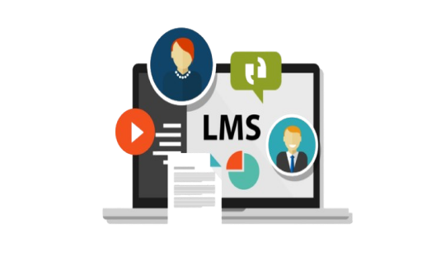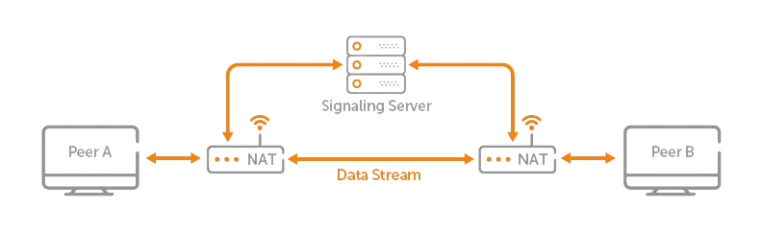

Figure 3.1 Work Flow of the system

The figure 3.1 illustrates a WebRTC-based communication architecture, highlighting its components and data flow. It includes two peers (Peer A and Peer B) communicating directly through a peer-to-peer (P2P) connection facilitated by a signaling server. The signaling server establishes the initial connection by exchanging metadata (like session descriptions and ICE candidates) but does not handle the media or data streams. The data stream flows directly between the peers after NAT traversal (Network Address Translation), ensuring real-time communication. Additionally, the diagram integrates a Learning Management System (LMS) to illustrate how such a system can utilize WebRTC for interactive educational purposes, connecting peers while leveraging centralized signaling.

## 3.2 Proposed System Design of WebRTC

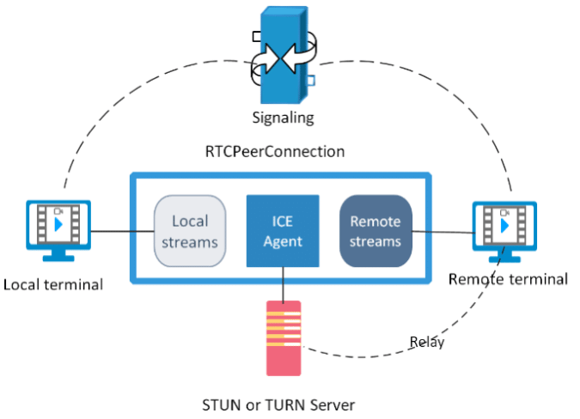

Figure 3.2 Proposed System Design of WebRTC

The figure 3.2 represents the architecture of WebRTC (Web Real-Time Communication) with a focus on the RTCPeerConnection process. It depicts the interaction between a local terminal and a remote terminal for establishing real-time communication. The signaling mechanism is responsible for setting up and negotiating the connection parameters. The RTCPeerConnection object includes three main components: Local Streams (media captured locally), ICE Agent (Interactive Connectivity Establishment), and Remote Streams (media from the other peer). A STUN (Session Traversal Utilities for NAT) or TURN (Traversal Using Relays around NAT) server facilitates NAT traversal or relays data if direct peer-to-peer connection fails. This architecture ensures robust communication even in complex network environments.

## 3.3 Overall Design of the System

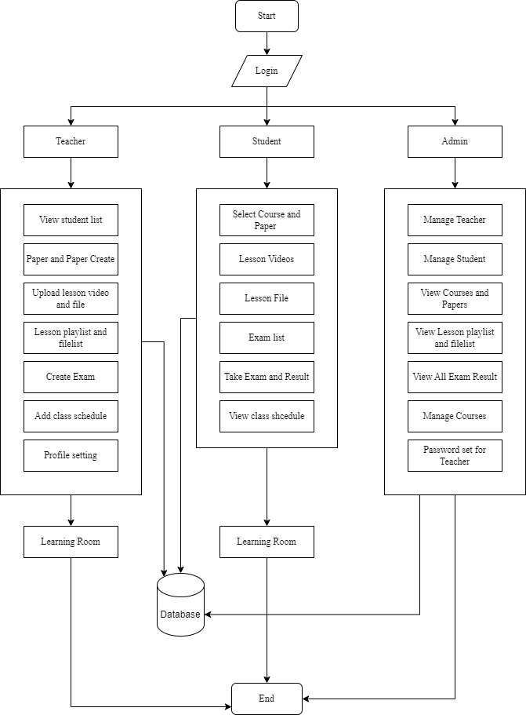

Figure 3.3 Overall System Design

The figure 3.3 illustrates the architecture and workflow of a Learning Management System (LMS), designed to cater to three primary user roles: Teacher, Student, and Admin. The system begins with a login interface, which serves as the entry point for all users. Upon successful authentication, users are directed to their respective dashboards, each tailored to their role-specific tasks and responsibilities. This role-based structure ensures that each user interacts only with features relevant to their needs, streamlining the management of learning processes.

For teachers, the LMS provides a comprehensive suite of tools to create, manage, and deliver educational content. Teachers can view student lists, create papers and exams, upload lesson videos and files, and organize these resources into playlists for easy access. Additionally, teachers can add class schedules and customize their profile settings, enabling them to plan and manage their teaching activities effectively. The learning room serves as a shared space where uploaded materials and exams are accessible to students, ensuring seamless interaction between instructors and learners.

Students are equipped with functionalities that focus on learning and assessment. They can select courses and papers, access lesson videos and files, view exam lists, and participate in assessments. After completing exams, students can view their results, helping them track their academic performance. They also have access to class schedules, which keeps them informed about upcoming lessons and deadlines. By providing these tools, the system ensures that students have all the resources necessary for their academic journey within a single platform.

The admin plays a crucial role in overseeing the system's operation and ensuring its integrity. Admins are responsible for managing teachers and students, handling course and paper-related data, and maintaining the system's database. They can view and monitor lesson playlists, exam results, and user activities to ensure compliance and quality. Additionally, admins have the ability to set passwords for teachers, safeguarding account security and controlling access. This centralized control allows the admin to maintain an organized and efficient learning environment.

The database serves as the backbone of the system, connecting all user activities and storing essential data. It ensures that information flows seamlessly between users and supports the learning room, where teachers and students interact. By integrating the activities of teachers, students, and admins, the LMS fosters a collaborative learning ecosystem. The figure demonstrates how the system uses well-defined processes to create an efficient, user-friendly platform for managing modern education.

## 3.3 Detail Design of Learning Room

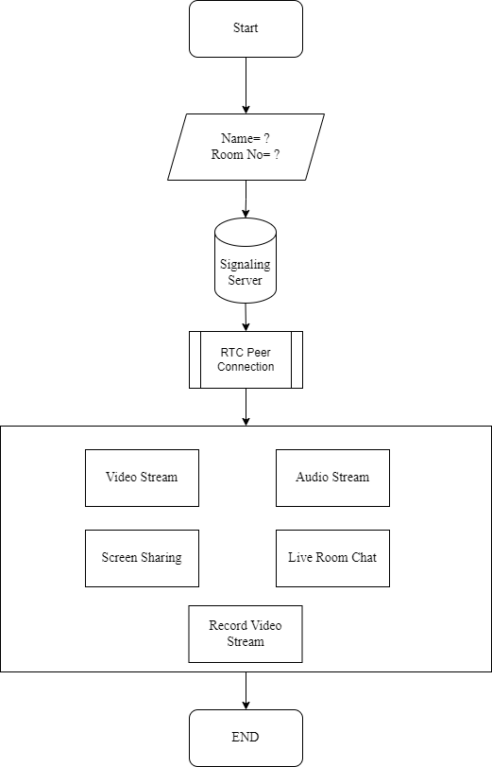

Figure 3.3 Overall System Design

The flowchart illustrates the process of establishing and utilizing a real-time communication (RTC) system with features like video streaming, audio streaming, screen sharing, and live room chat. The process begins with the user providing their name and room number, which serves as input for identifying or creating a communication session. This information is relayed to a signaling server, which facilitates the initial connection setup between clients by exchanging necessary data, such as session descriptions and network information.

Once the signaling server completes its task, the RTC peer-to-peer connection is established. This connection enables direct data exchange between users without involving the server further, ensuring low latency and efficient communication. The system supports multiple functionalities, including streaming video and audio, sharing screens, and participating in live room chats. Additionally, it allows for the recording of video streams, enabling users to save their sessions. The flow ends with the termination of the RTC session, marking the conclusion of the communication process.

## 3.4 Implementation

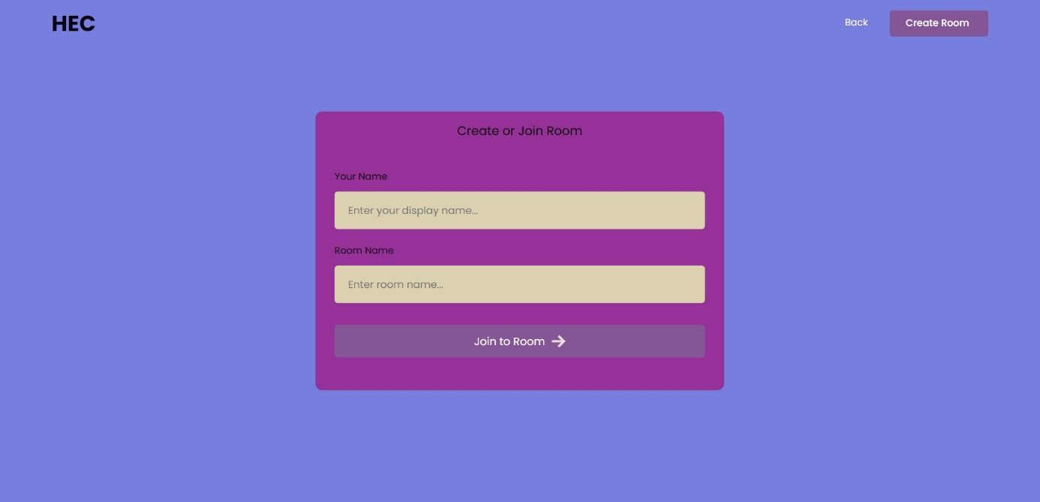

Figure 3.4 Learning Room Login Page

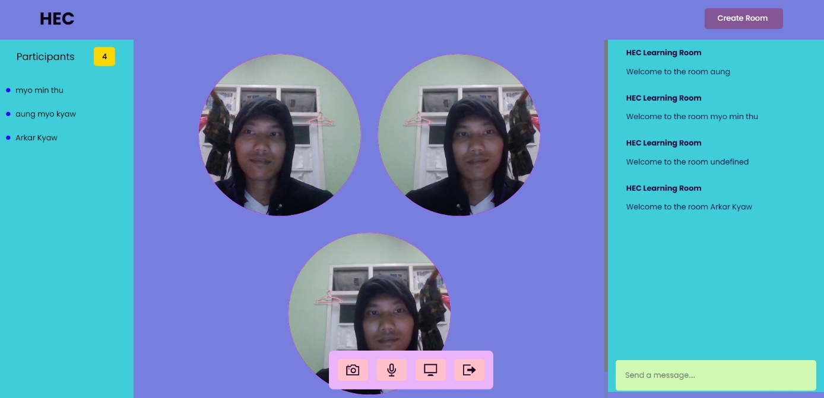

Figure 3.5 Learning Room Page with Multiple users

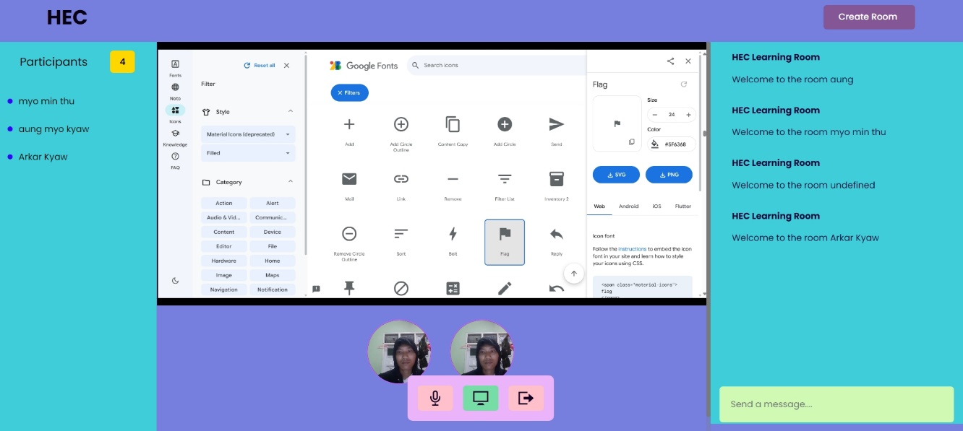

Figure 3.6 Learning Room Page with Screen sharing of Teacher

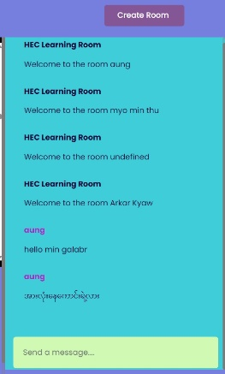

Figure 3.7 Learning Room Page with Live Chatting for all users

# CHAPTER 4

# CONCLUSION AND FUTURE WORK

## 4.1 Conclusion

The integration of WebRTC into Learning Management Systems (LMS) has the potential to significantly enhance real-time communication and collaboration in online education. This thesis explored the capabilities of WebRTC technology in addressing the limitations of traditional LMS platforms, such as delayed feedback, lack of real-time interaction, and limited support for synchronous communication. By leveraging WebRTC’s peer-to-peer architecture, low-latency communication, and support for multimedia data streams, the proposed solution provides an efficient and scalable framework for live video, audio, and data sharing within LMS environments.

Through the implementation and testing of a WebRTC-enhanced LMS module, this study demonstrated its effectiveness in improving user engagement, fostering collaborative learning, and supporting a more dynamic and interactive online learning experience. Key findings indicate that WebRTC can reduce latency, enhance accessibility across devices, and support seamless integration with existing LMS features without requiring extensive infrastructure changes.

Despite its numerous advantages, challenges such as network reliability, browser compatibility, and data privacy were also identified. Addressing these challenges requires ongoing efforts, including adopting advanced encryption protocols, optimizing bandwidth usage, and ensuring compliance with privacy regulations.

In conclusion, WebRTC represents a transformative technology for the future of online education. Its adoption in LMS platforms can bridge the gap between educators and learners, promoting a richer and more interactive learning experience. Future research should explore extending WebRTC applications in LMS to include AI-driven adaptive learning, augmented reality (AR), and further scalability for large-scale educational platforms.

## 4.2 **Benefits of the System**

The integration of WebRTC into Learning Management Systems (LMS) offers several benefits, enhancing the overall functionality and user experience of online education platforms. These benefits include:

1. **Real-Time Communication**  
   WebRTC facilitates low-latency, real-time audio and video communication, enabling live interactions between educators and learners. This fosters instant feedback, active participation, and dynamic discussions, replicating the classroom experience in a virtual environment.
2. **Improved Collaboration**  
   The system supports features like screen sharing, real-time file transfer, and group video conferencing, promoting collaborative learning among students and instructors. This enhances group activities, peer-to-peer learning, and teamwork in project-based courses.
3. **Ease of Access and Cross-Platform Compatibility**  
   WebRTC operates seamlessly across modern browsers and devices without requiring additional plugins or software installations. This ensures accessibility for users regardless of their device or operating system, making online education more inclusive.
4. **Cost-Effective Solution**  
   By leveraging WebRTC’s peer-to-peer communication model, the system reduces reliance on costly server infrastructure for data transmission. This makes it a cost-effective solution for educational institutions looking to implement advanced communication tools.
5. **Enhanced User Engagement**  
   The system enables synchronous interactions that are more engaging compared to traditional asynchronous methods like forums or email. Real-time communication helps maintain learner interest and motivation, leading to better educational outcomes.
6. **Scalability**  
   The lightweight and decentralized nature of WebRTC allows the system to scale efficiently to support a growing number of users. This makes it suitable for both small classes and large-scale online courses.
7. **Customizability and Integration**  
   The WebRTC-enhanced system can be customized to align with specific institutional needs and integrated seamlessly into existing LMS frameworks. This ensures continuity and ease of adoption for administrators and users.
8. **Support for Multimedia Content**  
   WebRTC supports high-quality audio, video, and data streams, enabling the sharing of multimedia content in real-time. This enriches the teaching and learning process by allowing the use of diverse instructional materials.
9. **Improved Bandwidth Optimization**  
   WebRTC’s efficient bandwidth usage ensures smooth communication, even in environments with limited connectivity. This makes the system more reliable for users in areas with inconsistent internet access.
10. **Enhanced Privacy and Security**  
    WebRTC includes built-in encryption protocols for secure data transmission, ensuring that all communications remain private and protected. This is especially critical in educational settings where data confidentiality is paramount.

By addressing the limitations of traditional LMS platforms and offering these benefits, the WebRTC-enhanced LMS system provides a transformative approach to online education, paving the way for more effective and engaging learning experiences.

## 4.3 Future Works

|  |  |  |  |
| --- | --- | --- | --- |
| **Seminar** | **Step of Research** | **Utilized software** | **Remark** |
| 1stSeminar | Background Theory and Literature Review, Proposed System Design for research work, LMS Creation | HTML, CSS, JS , | Now 30% |
| 2ndSeminar | Implementation and Data preparing | Mysql, Database | Now Yet |
| 3rdSeminar | Testing of WebRTC work on LMS Website and Results | Mysql, Database | Now Yet |
| 4thSeminar | Limitation, Further Extension, Benefits of the system | Mysql, Database | Now Yet |

REFERENCES

[1] Avi Kak, “*Web Security: PHP Exploits and the SQL Injection Attack*”, Avinash Kak, Purdue University, May 2, 2015.

[2] Brad Bulger, Jay Greenspan and David Wall, “MySQL / PHP Database Application”, Second Edition, Wiley Publishing Inc, United State of America, 2004.

[3] Channu Kambalyal, “*3-Tier Architecture*”, 2002.

[4] Eckerson, Wayne W. "Three Tier Client/ Server Architecture: Achieving Scalability, Performance, and Efficiency in Client Server Applications." Open Information Systems 10,1 (January 1995): 3(20)

[5] Ei Maung, “*Professional Web Developer*”, Second Edition, Fairway Web Development, June 2015.

[6] Gerald C.Okereke, “Database Management System”, National Open University of Nigeria, Nigeria, 2009.

[7] Ian Jacobs, “*Architecture of the World Wide Web, Volume One*”, W3C Norman Walsh, Sun Microsystems, Inc., December 2004.

[8] IT SECURITY CENTER (ISEC), “*How to Secure Your Website*”, Fifth Edition, Information-Technology Promotion Agency, Japan, April 2011.

[9] Jin Jiawei, “*Web-Based Library Management System with PHP and MySQL*”, Turku University, May 2011.

[10] Luke Welling, Laura Thompson, “*PHP and MySQL Web Development*”, Second edition, Sams Publishing, 201 West 103rd Street, Indianapolis, February 2003.

[11] Robin Nixon, “*Learning PHP, MySQL, JavaScript, CSS & HTML5*”, Third Edition, O’Reilly Media, Inc., 1005 Gravenstein Highway North, Sebastopol, CA 95472, June 2014.

[12] Taly Sharon and Ariel J. Frank, “*Digital Libraries on the Internet*”, Bar- Ilan University.

[13] Tony Johnson, “*Spinning the World Wide Web*”, Stanford University, 1994.

[14] “What is web server?”, Webdevelopersnotes. 2010-11-23. Retrieved 2010-11-23.

[15] "Website – definition of website by the Free Online Dictionary, Thesaurus and Encyclopedia". Thefreedictionary.com. Retrieved 2011-07-02.

[16] <https://en.m.wikipedia.org/wiki/Web_page>

[17] <https://en.m.wikipedia.org/wiki/Static_web_page>

[18] <https://en.m.wikipedia.org/wiki/Dynamic_web_page>

[19] <https://www.javatpoint.com/model-1-and-model-2-mvc-architecture>